**Supervisor**

**Mr. Bishnupada Kamila**

**By:**

Shrabanee Routray (230301120295)

Vasetti Dixita (230301120299)

Satyapriya Das (230301120308)

Vikash Das (230301120 )

Jyoti Anurag (230301120 )

**ST(C)**

**B.TECH(CSE)**

(SRS DOCUMENT)

FOR

**HOTEL MANAGEMENT WEB APPLICATION**

**SOFTWARE REQUIREMENTS SPECIFICATION**

**Hardware Requirements:**

* **Processor:** Dual Core / Dual Core2Duo or above.
* **RAM:** 4GB or above.

**Software Requirements:**

* **Operating System:** Windows, Mac.
* **Code Editor/IDE:** Visual Studio Code, IntelliJ.
* **Database Application:** MySQL Workbench.
* **Technology:** Angular, Spring Boot

**Software Requirement Specification (SRS)**

**Introduction**

**Purpose**

The purpose of this document is to outline the software requirements for a Hotel Room Booking Application. This application aims to provide a seamless and user-friendly platform for customers to book hotel rooms.

**Scope**

The application will allow users to view room details, book rooms, and manage their bookings. The backend will be developed using Spring Boot, the frontend with Angular, and MySQL Workbench will be used for the database.

**Overall Description**

**Product Perspective**

The application will be a standalone product, accessible via web browsers.

**Product Features**

- User Registration and Authentication

- Room Booking

- Booking Management

**System Features**

**Backend - Spring Boot**

The backend of the application will handle business logic, user authentication, data storage, and retrieval. It will interact with the MySQL database to store and fetch data.

**Frontend - Angular**

The frontend of the application will provide a user-friendly interface for users to interact with the application. It will communicate with the backend to fetch and display data.

**Database - MySQL Workbench**

MySQL Workbench will be used to design and manage the application's database. It will store all the application data including user details, hotel details, and booking details.

**Functional Requirements**

* **User Registration and Authentication:** Users should be able to register and create an account using their email. Users should be able to log in to their account using their email and password.
* **Track/Search of Available Room:** The system should be able to track and search for available rooms.
* **Booking/Reservation:** The system should keep track of reservations, customer’s first and last name, number of occupants, room number, default room rate, customer’s phone number, and whether the room is assured.
* **Responsive Booking Engine:** The system should have a responsive booking engine that includes auto email including popups and welcome message.
* **Cancellation/Modification:** The system should allow users to cancel or modify their bookings.
* **Make Payment:** The system should be able to process payments.
* **Incorporation for Hotel Staff:** The system should allow hotel staff to book rooms, send confirmation emails, issue bills, add and update guest list, and generate reports

**Non-Functional Requirement**

* **Performance Requirements:** The system should be responsive and able to handle multiple bookings and other operations simultaneously without performance degradation.
* **Security Requirements:** The system should have different user levels with login credentials to control access to system functions based on role. User data should be stored securely. Passwords should be hashed and not stored in plain text. Secure HTTP (HTTPS) should be used for all communications between the client and server.
* **Software Quality Attributes:** The system should be reliable, maintainable, and user-friendly.
* **Availability Requirements:** The application should be available for use 24/7, barring scheduled maintenance periods.

**IMPLEMENTATION:**

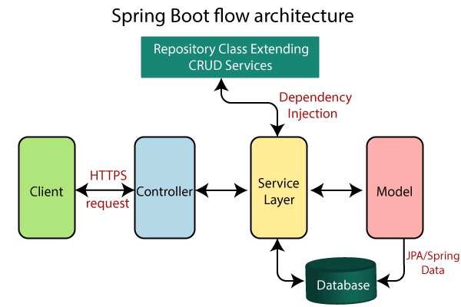

**ER DIAGRAM:**

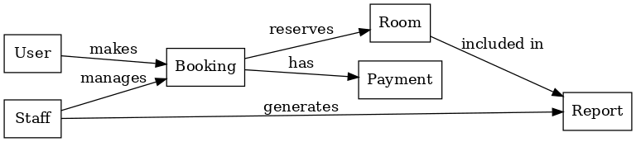

**USE-CASE DIAGRAM:**

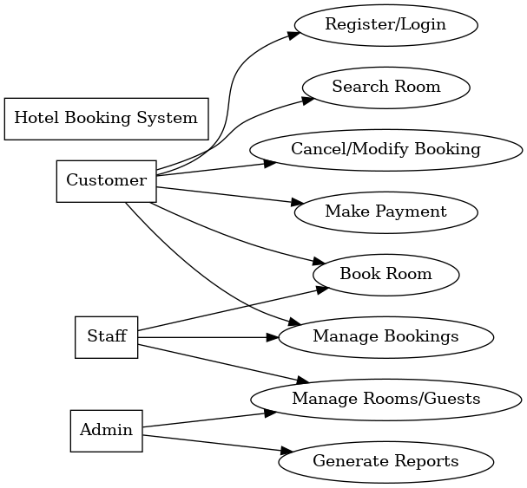

**ACTIVITY DIAGRAM:**

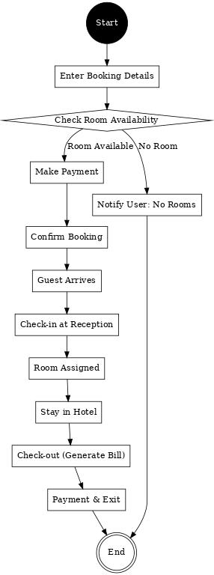

**Problem Statements**

* **Inefficient Traditional Booking System**  
  Many hotels still rely on manual booking processes or outdated systems, which are prone to errors, double-bookings, and inefficiency. This creates inconvenience for both customers and hotel staff.
* **Limited Accessibility for Customers**  
  Customers often face difficulties in checking real-time availability of hotel rooms and managing their bookings remotely. A lack of an online booking system limits accessibility and reduces customer satisfaction.
* **Poor Booking Management for Hotels**  
  Without a centralized system, hotel staff struggle to efficiently manage reservations, customer details, payments, and cancellations. This leads to operational inefficiencies and data inconsistencies.
* **Security Concerns in Existing Systems**  
  Many existing booking systems do not properly secure customer data such as personal details and payment information, increasing the risk of unauthorized access and data breaches.
* **Lack of Integrated Features**  
  Existing solutions often fail to provide an all-in-one platform that supports user registration, authentication, payment processing, booking modification/cancellation, and staff management features in one place.